**PSM10 Installation experience report**

PSM 10 - 4kW (FAL10KWh - 4 kW)

Date of completion: 2019-10-01

Assignment carried out by:

Christer Rygaard (sunnyfuture)

Liang Tian (esol.tech)

Customer:

**Bengt Engwall**

Address:

Konvaljevägen 2, 183 30 Täby

**Time log:**

|  |  |  |  |
| --- | --- | --- | --- |
| **Date** | **Time** | **Event** | **Note** |
| Oct 01 | **11:10** | Leaving from FerroAmp | Trailer loaded with Christer |
|  | **11:35** | Arriving at the site |  |
|  | **11:40** | Unloading / discussion |  |
|  | **12:00** | Cabinet levelling |  |
|  | **12:33** | Cabinet mounted to the wall |  |
|  | **12:55** | All modules inserted |  |
|  | **13:10** | Fixing AC 230 cable / wiring | BMS updated |
|  | **14:00** | Junction box, DC link cable |  |
|  | **15:00** | Demo charging / discharging using PC terminal |  |
|  | **15:13** | Taking pictures / Leaving the site | Christer gave oral summary |

**Summary:**

Arrived with Christer at the customer’s house 11:35 after loading cargos at FA production earlier in the morning. After a brief talk with the customer, Liang started to work with Christer.

The wall prepared at the customer site is inside a garage where one Ehub is nicely installed with 2 SSOs mounted side by side. According to Christer, Bengt the customer is the first to have complete FA system installed by Sunnyfuture.

The cleared space for the cabinet is enough to have the battery module inserted from either side. It was decided on site the battery modules are to be inserted from the right-hand side which turned out to be exactly what was recommended in the installation manual. It was very soon found out that the concrete floor is not even. The time spent on leveling the cabinet was longer than expected as the buyer of the system has a very high requirement.

The installer was noticed in advance that he was expected to do all the installation by himself. However, Christer did not have an printed installation manual in hand. Liang did go through the whole procedure using his laptop. Liang also at times offered help for the installation work, including examining the junction box, part of the mounting, the cable connection etc. Christer built DC link cable using the standard cable (6mm2) for PV installation.

The cabinet was mounted against a gravel brick wall. The whole installation followed exactly the way illustrated in the installation manual. After the switching on the system. The ESO lit up red fault LED. Liang then connected the ESO using a PC laptop to configure the system and demonstrated the system function charging / discharging etc. The system was properly displayed from the portal before leaving the site.

Christer summarized the whole work done in front of the customer and collected all the boxes, packaging materials. The customer’s site was nice and clean.

This concluded the installation of the PSM 10 system.

The next section is photos from the installation followed by the customer comment. A worth mentioning section is at the last of this report.

**Photos from the installation.**

**(with *Liang’s comment* under each photo)**

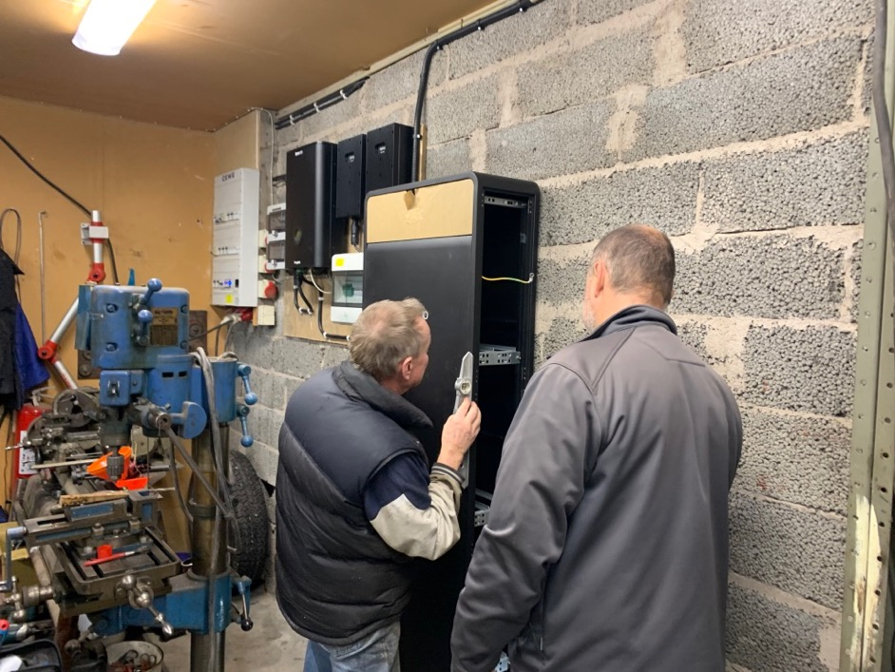

**Photo 1.**

The customer was very carefully levelling the cabinet by himself.

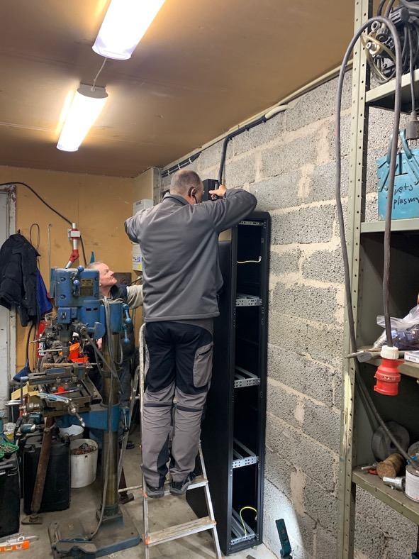

**Photo 2.**

Continued leveling by Christer

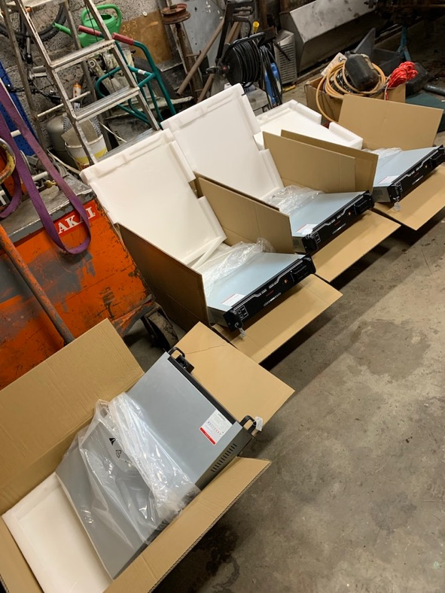

**Photo 3.**

While the customer and Christer was busy leveling the cabinet. Liang did the unboxing and wrote down all the serial number.

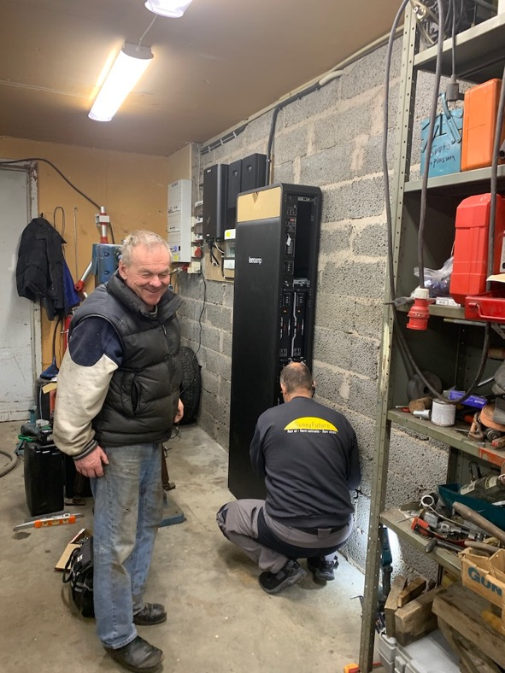

**Photo 4.** The mounted cabinet and the battery installation

The 10kWh batteries were all inserted into the cabinet while the bottom two slots were left empty. In case of future upgrading, it is easy to upgrade by inserting two extra battery modules from the bottom. The cables (for 15kWh system) came along with the system was stored inside the cabinet.

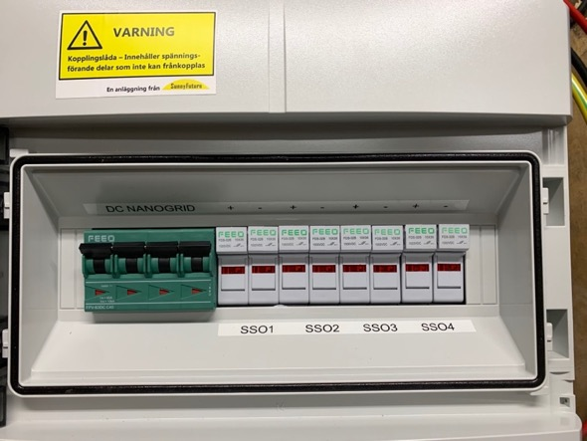

**Photo 5.** The junction box

SSO1 and SSO2 are occupied. The battery was connected to SSO4. Christer later changed the label after the installation

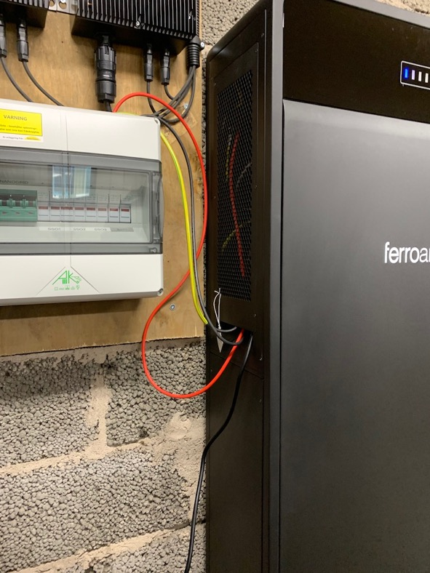

**Photo 6.**

DC link cable built by Christer. Christer mentioned that he would call in an electrician to a better job.

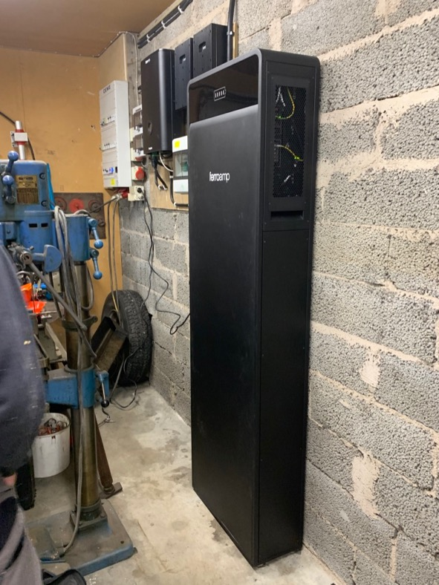

**Photo 7 system up and running**

Liang managed to configure the system directly from the ESO.

The battery was recognized from the portal showing correct SOC and rated capacity. By the time Liang leaving the site, the system was set to topping up the battery. The customer was happy to see the system already from the mobile phone.

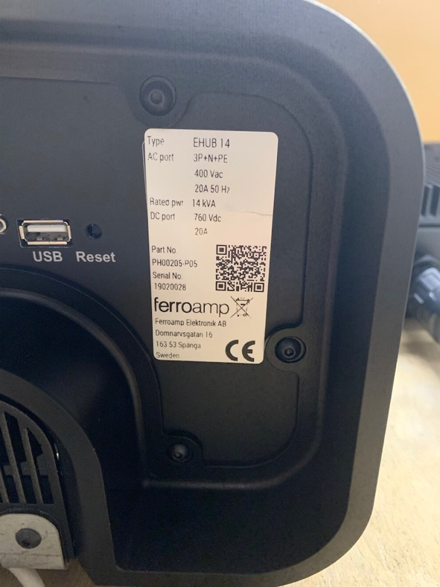

**Photo 8.** The Ehub

Liang examined the EHub which is in good working condition.

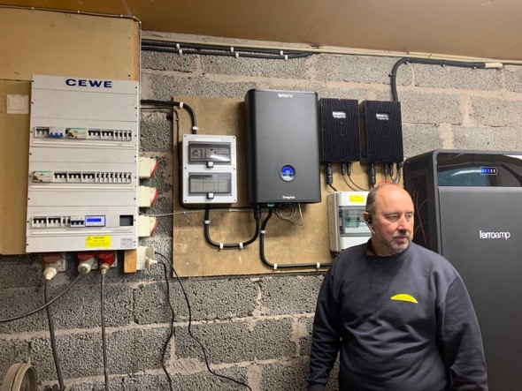

**Photo 9.** The completion

Christer orally summarized what has been done to the customer after the installation.

**Customer’s comment**

1. to the installation manual

|  |  |  |
| --- | --- | --- |
|  | **Comments by customer** | **Comment by Liang** |
| 1 | The manual shall come in the box | Noted  It is not clear yet either FA or ESOL shall print out the manual.  Esoltech believes that it would be more environmentally friendly sending the installation manual only in electronic format. |
| 2 | The AC cable should come with cable terminal shoe | Noted |
| 3 | The AC cable should be fixed to the AC junction panel instead of using an AC 230 socket solution | Noted; to be figured out |

2. to the generic installation

|  |  |  |
| --- | --- | --- |
|  | -- | -- |
| 4 | Installer may need more information, since the electrician may not be present during the work | Christer is a very experience installer but not necessary an electrician. So it might be good to emphasize the information related to the part normally done by an electrician in the installation manual |
| 5 | ESO is not preconfigured | The Fault indicator on the ESO lit up (red) as soon as the system is powered on. This can cause panic since unexperienced customer is not informed on what to expect.  It is possible to include this part as a “precaution” in the PSM installation manual. It is needed however that FA and ESOL.tech agree on a meaningful way of product shipping for future delivery. |
|  |  |  |

**Worth mentioning**

1. the cable upgrade



**Photo 10.** Nice and tidy cable upgrade shot on Oct. 15

The thin white cable is from AC junction box (left) to the cabinet (controller power), and

the thicker white cable from the DC junction box to the cabinet (DC-link).

2. What Liang understands from Bengt’s installation:

* The existing installation has two SSOs
* The main fuse to the grid is 20A (downgraded from 25A before the FA system installation)
* Bengt is an earlier adapter to the FA system and he has been very happy with it since the installation two years ago

3. What is expected (configuration) from the FerroAmp PSM system:

* Topping up the battery during the daytime during the season with abundant sun light.
* Maintain the longevity of the battery during the cold dark season.

3. Liang’s generic impression for the installation:

* The customer has a very high requirement for installation quality
* The junction panel was very nicely built by professional
* FEEO brand MCB / fuse holders were installed at the customer site.

4. Additional comment for the ESO preparation / packaging:

* Liang picked up ESO directly from the production that was pre-assembled with the adaptor and the front plate
* The pre-assembled ESO is difficult to transport; Liang has found a walkaround:

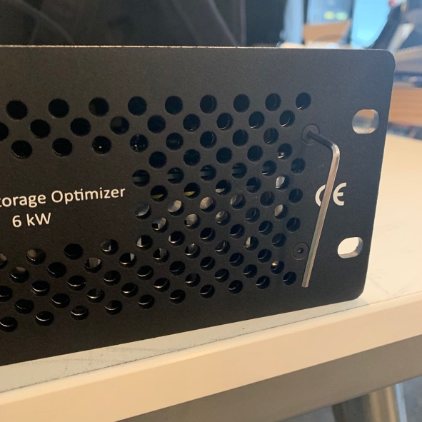

**Photo 11.** The ESO with front plate

An ideal way for ESO transportation is to ship it with the front plate removed. However, Liang found it not possible to untighten the screw as it was so firmly fastened.

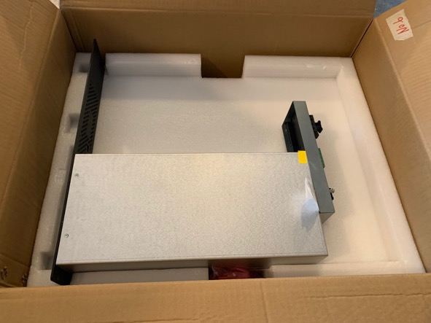

**Photo 12.** Temporary fix for ESO shipping package by using a Sunwoda carton box

Note that when shipping with only one ESO, the whole assembly is not as sturdy compared to Duo-ESO configuration thus must be handled with care. It is not allowed to lift the assembly by holding only the ESO adopter (only two screws are used between the two).

One SU canton box (the box used for the sample rack at FA showroom) was used to ship the preassembled ESO. The whole assembly fits nicely into the pre-cut protective foam made for the SU battery module.

There can be better packaging solution presumably done by FA.

**(This is the end of the report.)**